





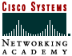

President’s Statement

Border Institute of Technology (BIT) specializes in curriculum to meet the needs of students who are job and career oriented. The students who make up the student body of BIT are seeking a nontraditionally structured education that can launch them into a diversity of careers. Each of the program offerings is impacted by the various training vehicles that will supply the students with qualifications for more competitive standing and achievement of employment opportunities.

BIT faculty members are selected for their academic qualifications and their “real world” business experience. As professionals in the fields in which they teach, BIT faculty members bring the students the benefits of their practical professional experience by providing a healthy balance of textbook theory and up-to-date business application to the classrooms.

Stephen H. Simon

Accreditation
Border Institute of Technology is accredited by Accrediting Commission of Career Schools and Colleges of Technology (ACCSCT).

Approvals
BIT is approved and regulated by the Texas Higher Education Coordinating Board, Austin, Texas. Additional approval is by the Texas Workforce Commission Proprietary Schools Section, Austin, Texas, and Veterans Vocational Rehabilitation, and State of Texas Vocational Rehabilitation.

Admission Requirements
Border Institute of Technology requires for admission into its programs a high school diploma or recognized equivalency certificate or evidence of successful completion of the equivalent of one full-time semester (12 semester hours) or quarter (18 quarter hours) at an accredited college, university, or post secondary institution.
The Admissions office is open Mondays through Fridays from 8:00 a.m. to 7:30 p.m., Fridays from 8:00 a.m. to 5:00 p.m, and Saturdays 10 a.m. to 12:00 p.m.

Financial Aid
The following Federal Programs are available for those who qualify in the following forms:
FPELL: Educational (Pell Grant)
FSEOG: Supplemental Education Opportunity-Grant
FCWS: College Work Study
Fstafford Loans: Guaranteed Student Loans
FPLUS: Parent Loans for Undergraduate Students

Schedule
Classes are scheduled between 8:30 a.m. to 9:30 p.m. on weekdays. Individual class schedules vary by major from quarter to quarter and are predetermined by computer scheduling.

Placement Service
The academic training received at Border Institute of Technology helps to prepare students for a challenging career. Upon graduation, or any time thereafter, graduates may avail themselves of the schools lifetime placement services.

Business Management
Associate of Applied Sciences
Today’s business world is one of excitement and opportunity. It offers a trained leader a challenging, professional future. The Business Management program’s curriculum at Border Institute of Technology has been designed to ensure a substantial educational preparation. Courses are designed to introduce the student to the entire field of Business Management and provide a sound knowledge of modern business practices.
Careers in Business Management include the following: Graduates in Business Management qualify for entry-level positions in areas such as these: Accounting, Marketing, Advertising/Promotion, Office Management, Economics, Personnel, Finance, Purchasing, Management, and Sales.

Microcomputer Applications
Associate of Applied Sciences
The Associate of Applied Sciences Degree program was created to meet the technical demands on business and industry presented by the inexpensive microcomputer and the very powerful software which followed. The program emphasizes commercial software applications.
Careers in Microcomputer Applications include the following: Computer Draftsman, Database Manager, Maintenance/Upgrade Technician, Micro-Program Trainer, Software Engineer, Micro-Application Programmer, and Windows Support Personnel.

Web Merchandising Technology
Associate of Applied Sciences
The Merchandising Technology curriculum helps students build skills in business concepts such as E-commerce, marketing, retailing, merchandising management, microcomputer literacy, communication, and merchandise operations. Advanced computer technology has been incorporated into the Merchandising Technology program to allow students to learn and apply state-of-the-art techniques.
Merchandising Technology graduates qualify for entry-level: Assistant Buyer, Assistant Store Manager, Catalog Manager, Department Manager, E-Commerce Specialist, Inventory Control Specialist, Promotional Manager, Special Events Coordinator, Small Business Owner, Visual Merchandiser.

*Hands-On P.C. Technology
Certificate of Completion
This certificate program can be taken in 11-week segments, or 3 quarters. The computer educational program is comprised of intensive, hands-on, step-by-step training. A compatible IBM computer is furnished at the school so that individuals can set their own study pace outside of scheduled class time.
Students who complete this certificate program will achieve competency in the Microsoft Office Professional Software package as well as learn the fundamentals of networking. Use of Internet browsers and email are covered as well as their integration into the Microsoft office suite of applications. Preparation for the Microsoft Office User Specialist Certification is integrated into the curriculum if the student wishes to pursue it. The hardware classes prepare the student for A+ Hardware Certification if the student wishes to pursue that also.
Hands-On P.C. Technology Certificate of Completion will prepare you for entry level positions in: Maintenance Upgrade Technician, Technical Support Personnel, Micro-Telecommunications Technician, LAN Technician, or Automated Office Specialist.

*Program is transferable to Associate Degree Program

*Network Technologies
Certificate of Completion
BIT leads the way by equipping its students with a strong combination of academics and in-depth, hands-on training. Upon Completion of a well rounded core of computer skills, students may choose between Cisco, Novell, and Microsoft certification courses for credit, or a combination, all coupled with A+ and Net+ certifications from Comp TIA.
Graduates of BIT have the prestige of being highly sought after in the technical world, fulfilling positions as Network Administrators in their certification field.

*Program is transferable to Associate Degree Program

*Web Design
Certificate of Completion
A graduate of this certificate program is allowed to let their creative mind take control of his or her career. This exciting fast-paced career is for those who want to become a part of the ever-expanding World Wide Web. There is a growing demand for these highly trained professionals, who can earn impressive salaries, developing, designing, and maintaining web sites. A graduate of this program may be designing web sites for a local mom-and-pop video rental store to a multi-national insurance company. The possibilities are endless.
BIT will introduce you to some of the most creative software applications and technologies available. Microsoft Front Page, Adobe Photoshop, Premier, Pagemaker, and Illustrator, Macromedia Flash, Ultradev, and Cold Fusion, are just some of the cutting edge tools you will use in the Web Design Program. Platforms are taught on both Apple and Windows based computers.
The Web Design Certificate program will prepare you for careers in: Web Designer, E-Commerce Site Builder, Digital Photographer, Digital Videographer, Digital Video Technician, Computer Illustrator, Graphic Designer, Interactive Developer or Multimedia Designer.

*Program is transferable to Associate Degree Program

*CADD Technology
Certificate of Completion
Today’s ever growing world and new technology demands highly trained Computer Aided Drafting and Design (CADD) personnel. Actual designs can be visualized before they are constructed, allowing products to be built and marketed at a faster pace than ever before. CADD operators are employed in fields such as architecture, manufacturing, construction, and engineering. CADD is now used in all phases of the design and manufacturing process, from 2D design and technical drawings to 3D models and prototypes.
BIT will introduce you to some of the most creative software applications and technologies available in Computer Drafting and Design: Autodesk AutoCAD and Adobe Illustrator are just some of the cutting edge tools you will use in the CADD Technology program. BIT provides a professional CADD facility, giving students the tools and the knowledge to draft and design with computers upon graduation. Platforms are taught on both Apple and Windows based computers.

*Program is transferable to Associate Degree Program

Network Security
Certificate of Completion
Graduates of BIT have the prestige of being highly sought after in the technical world, fulfilling positions as entry level Security Professionals. Security professionals are dedicated to insuring the risks associated with security threats are reduced by assessing and implementing countermeasures. Graduates of this program demonstrate knowledge of security operations, forensics, counter hacking, and problem solving.

The information in this catalog is true and correct to the best of my knowledge.
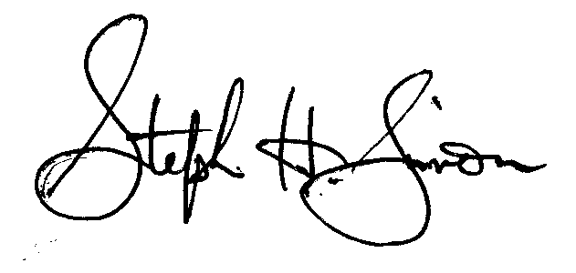
Stephen H. Simon
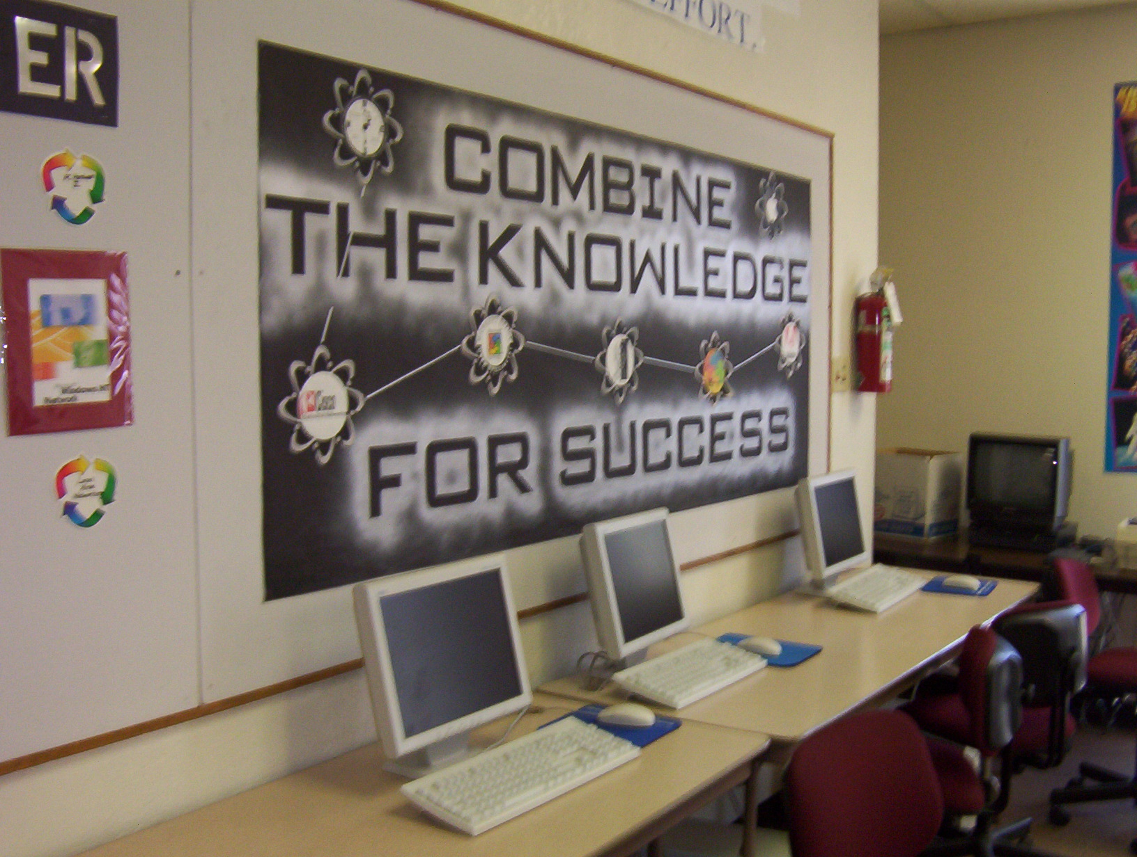
Academic Calendar

Winter Quarter 2004
December 13—March 4

Spring Quarter 2005
March 21 – June 3

Summer Quarter 2005
June 20—September 2

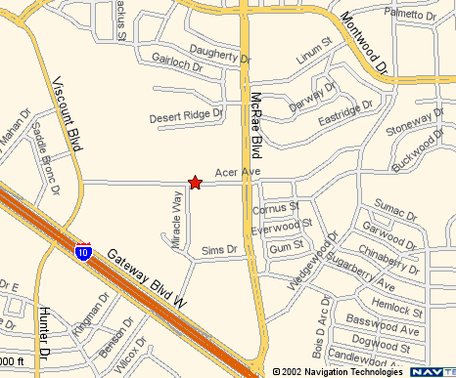

CALL US NOW!
ADMISSIONS OFFICE
(915) 593-7328 EXT. 24
OR AT THE WORLD WIDE WEB AT: www.bitelp.edu

